
Page 1 of 1

Lorraine Cordell

From: JOSEPHINE WARD Josephinewardsolicitor@gmail.com)
Sent: 08 August 2013 11 :21
To: Lorraine Cordell
Subject: Simon's court attendance notes for 16th July 2013
Attachments: Brief for the Defendant.pdf.
9 Client Care Mags Letter.doc

Lorraine I Simon

Please see the barrister's back sheet from the 16th of July 2013. This should have been forwarded onto you and would have been by me if it had been emailed to me in Bulgaria. Case workers are not allowed to send over any paperwork on any client file without prior authorization from the Solicitor with conduct, namely me. I cannot criticize the case workers for this as I am pretty strict on this.

If this had been emailed over to me in Bulgaria, then I would have emailed on it but as I was on annual leave the case workers viewed this as non-urgent as the Judge refused to vary the conditions.

I am also emailing you the client care letter again which outlines the complaints procedure.
Regards
Josephine

PS As indicated, when the case papers are served, and the secondary disclosure served then it may be possible to make a further attempt to vary bail but at this stage I do not believe that the Court will entertain it.

13/12/2013
Dec 00 02:52

p.7

Woolwich Crown Court

Date: l 61h July 2013

CORAM: HHJP Shorrock
CONTRA: Mr. Morgan

T2013064-9

- Case listed in Court 2 at 10am for Mention and Ball variation.
- Conference with Defendant.
- case called on. Application to vary bail is opposed.
Representations on behalf of Defendant.
- The judge was reluctant to Vary bail as he deemed.
Defendant to be capable of arranging replacement or cover for any work commitment.
- Defendant released on Conditional Ball:
- Live & sleep each night at 109 Burncroft Avenue, Enfield EN3 7JQ.
- Doorstep curfew between 8pm & 6am:
- Report to Edmonton Police station daily between the hours of 10am & 12pm:
- Not to enter the London Borough of Southwark.
- Passport to remain surrendered to Police.

Next Hearing:
4th September 2013
41
Woolwich Crown Court
(PCMH)

F.A.O, Josephine Michael Carroll & Co, Solicitors,
798, High Road, Tottenham, London
N17 DOH
Supplier No:
Tel No: 020 8365 9900
Fax No: 02D 8365 0500
Vinesh Boodhoo
16th July 2013

Travel: 2 hours
Waiting: 45 mins
Prep: 20 mins
Conference: 20 min,
Advocacy: 10 mins
Travel Cost: 10.00

R

-v-

Simon CORDELL

Brief for the Defendant

Counsel: Mr. Vinesh Boodhoo

Cranford 5
Chambers
8 Warwick Court
Grays Inn London WC1R5DJ

Tel: 020 7404 7454
Fax: 020 7430 0478
Legal Aid

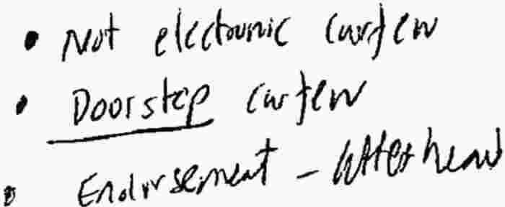
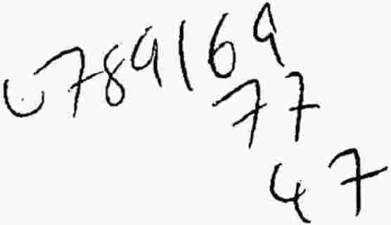


Principal: Michael Carroll LLB HONS
Office Tel No: (020) 8365 9900

This firm is authorised and regulated by the Solicitors Regulation Authority Reference Number: 00307837

Our Ref-

Private & Confidential

Dear

Michael Carroll & Co
Solicitors
798 High Road
Tottenham, London N17 ODH
DX 36206 EDMONTON 1
Fax (020) 8365 0500
Emergency No: 07970 617 644

Email : Josie@michaelcarrollandco.com

Youri Réf :

Date:

RE: YOUR CASE AT
DATE OF HEARING:
ALLEGATION:
MAGISTRATES COURT I CLIENT CARE

I thank you for instructing this firm to act on your behalf in relation to defending the criminal charge(s) you face. I will now confirm and summarise a number of matters relating to your case and your representation.

RESPONSIBILITY OF WORK

I am a qualified Solicitor and will be personally responsible for your case. If I am unavailable, then you can also contact who will either be familiar with your file or will at least take a message. The name of the solicitor having overall supervision of your matter is Michael Carroll. Kindly note that the office opening hours are between
9:00am and 5:30pm Monday to Friday.

REPRESENTATION ORDER
As you have been charged to attend Court for the above allegation, then providing the case is serious enough, you should be entitled to representation under the terms of a Representation Order, subject to a financial means assessment. If an application form has not already been completed and explained, then it will be at initial Court hearing. Representation if granted is free in the Magistrates’ Court. The costs themselves are paid by the Legal Services Commission. However, if your case is dealt with in the Crown Court, then you may be liable, subject to your means, to contribute to the Defence costs.

ORDER FOR COSTS

If you are found not guilty or the case is discontinued, you may be entitled to claim your out-of-pocket expenses and disbursements. However, if you plead or are found guilty, then
the Court may order you to pay part or whole of the Prosecution's costs of bringing these proceedings against you.

ADVICE

Your case can be dealt with in a variety of ways, depending on whether you are an adult or a youth. Depending on the seriousness of the charge, this may result in your case being dealt with in the Crown Court. My colleagues and I will explain the procedure to you in detail, at the appropriate time.

Information regarding your case will be updated regularly. You will be advised if another.
A solicitor from this firm will attend on your behalf any future hearing.

BAIL

If you have been granted conditional bail by the Court or Police, then you are obliged to comply with each and every bail condition. If you fail or neglect to do so, you will be liable for immediate arrest and possibly remand in custody. You are further reminded that failure to surrender to your bail at the Court that this is a separate offence for which, if you were found guilty, may be liable to a fine and/or imprisonment.

I shall, of course, keep you fully informed of any development in your case.

COMPLAINTS

We are obliged in this letter to inform you of our complaint’s procedure. Michael Carroll & Co is committed to high quality legal advice and client care. If you are unhappy about any of the services that you have received, please contact Michael Carroll on the office telephone number or by posted letter to our office or by email using the email contained in the letterhead. We have a procedure in place which details how we handle complaints. This is available on request.

If you are not satisfied with our handling of your complaint, you can ask the Legal Ombudsman to consider your complaint. They may be contacted at the Legal Ombudsman, PO Box 6806, Wolverhampton, WV1 9WJ. Normally you will need to bring a complaint to the Legal Ombudsman within six months of receiving a final written response from us about your complaint.

If you have any questions or I can help you in any other way, then please do not hesitate to contact me.

Yours sincerely,

Josephine Ward
MICHAEL CARROLL & CO

